### **Git Project**

#### **Objective:**

Worked on a project involving a simple website. Learnt and practiced various Git concepts including branching, merging, handling merge conflicts, rebasing, pulling, versioning, and rolling back changes.

#### **Project Setup**

1. **Installed Git**

**Set Up Git**: Configure your Git username and email:  
git config --global user.name "Your Name"

git config --global user.email "your.email@example.com"

1. **Created a GitHub Repository**:

Go to GitHub and create a new repository named website-project.

Clone the repository to local machine:  
git clone https://github.com/your-username/website-project.git

1. **Initialize the Project**:

Navigate to the project directory:  
cd website-project

Create initial project structure:  
mkdir src

touch src/index.html

echo "<!DOCTYPE html><html><head><title>My Website</title></head><body><h1>Welcome to my website!</h1></body></html>" > src/index.html

Commit and push the initial project structure:  
git add .

git commit -m "Initial commit: Added project structure and index.html"

git push origin main

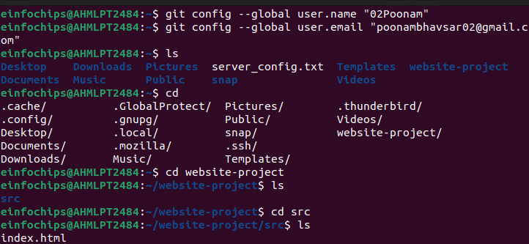

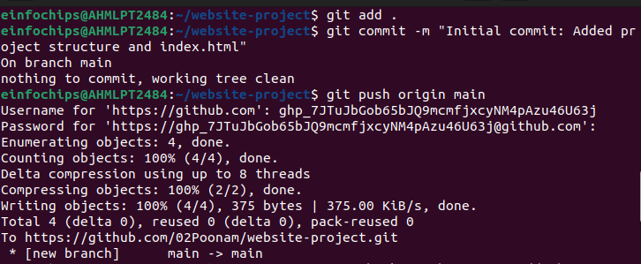

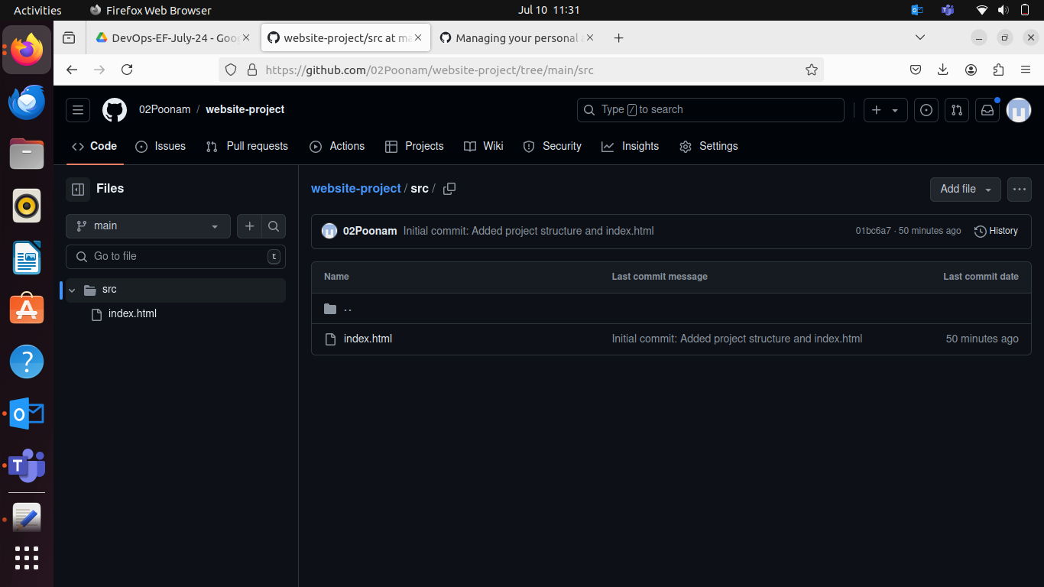

#### **Exercise 1: Branching and Basic Operations (10 minutes)**

**Create a New Branch**:  
  
git checkout -b feature/add-about-page

1. **Add a New Page**:

Create about.html:  
touch src/about.html

echo "<!DOCTYPE html><html><head><title>About Us</title></head><body><h1>About Us</h1></body></html>" > src/about.html

Commit and push changes:  
git add src/about.html

git commit -m "Added about page"

git push origin feature/add-about-page

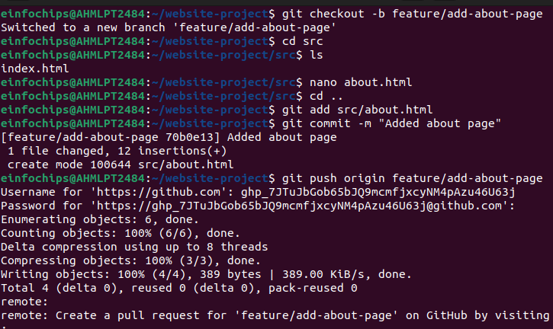  
  
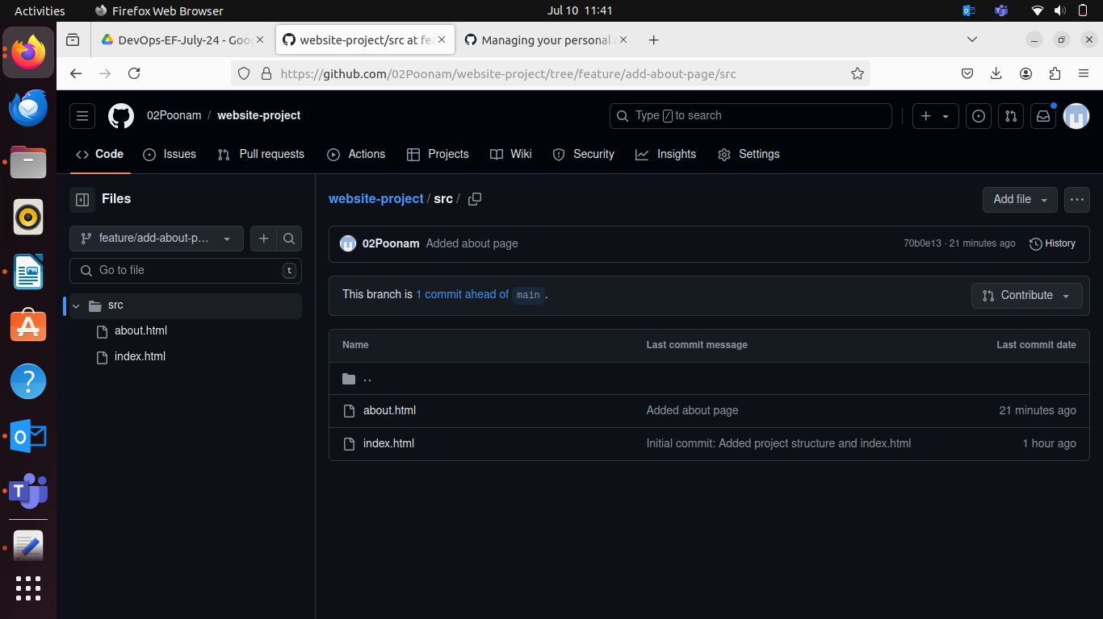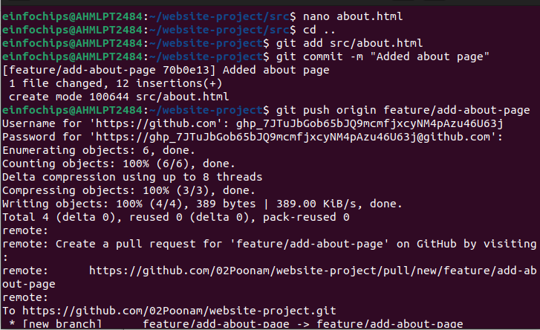

#### **Exercise 2: Merging and Handling Merge Conflicts (15 minutes)**

**Create Another Branch**:  
git checkout main

git checkout -b feature/update-homepage

1. **Update the Homepage**:

Modify index.html:  
echo "<p>Updated homepage content</p>" >> src/index.html

Commit and push changes:  
git add src/index.html

git commit -m "Updated homepage content"

git push origin feature/update-homepage

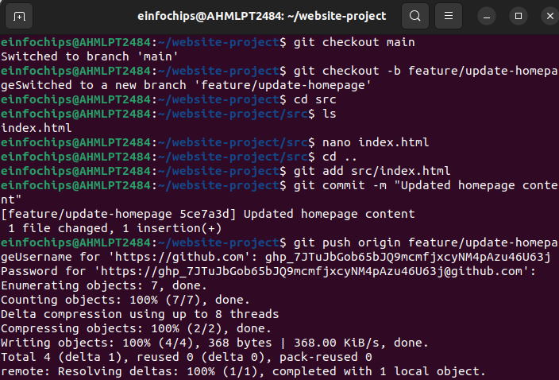

1. **Create a Merge Conflict**:

Modify index.html on the feature/add-about-page branch:  
git checkout feature/add-about-page

echo "<p>Conflict content</p>" >> src/index.html

git add src/index.html

git commit -m "Added conflicting content to homepage"

git push origin feature/add-about-page

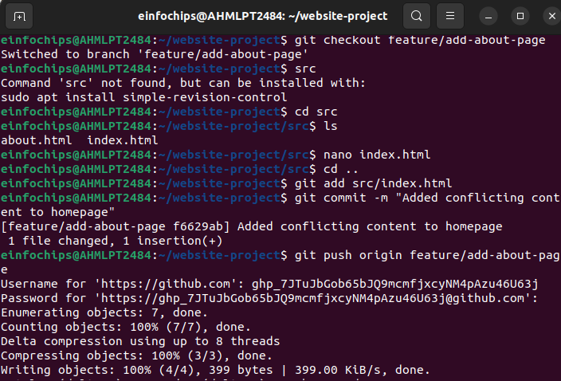

1. **Merge and Resolve Conflict**:

Attempt to merge feature/add-about-page into main:  
  
git checkout main

git merge feature/add-about-page

Resolve the conflict in src/index.html, then:  
git add src/index.html

git commit -m "Resolved merge conflict in homepage"

git push origin main

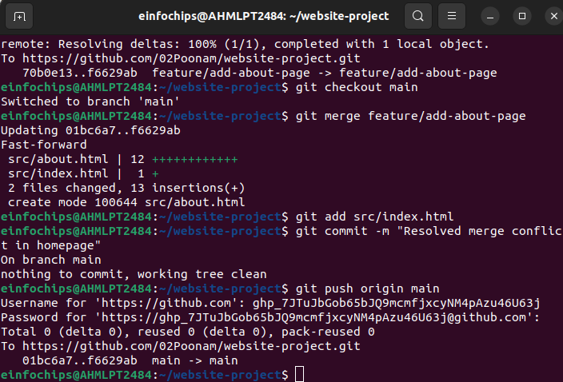

#### **Exercise 3: Rebasing (10 minutes)**

1. **Rebase a Branch**:

Rebase feature/update-homepage onto main:  
git checkout feature/update-homepage

git rebase main

* + Resolve any conflicts that arise during rebase.

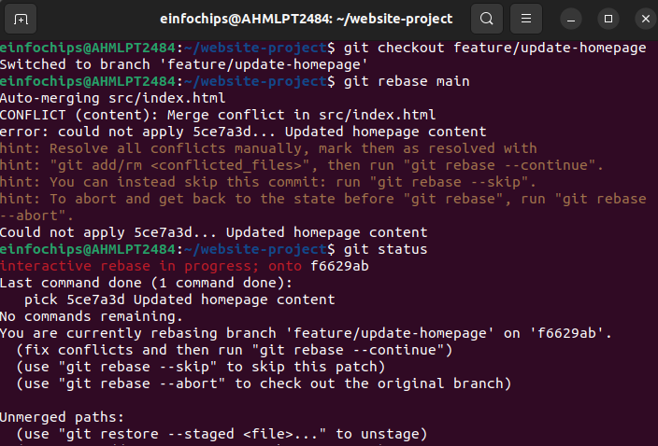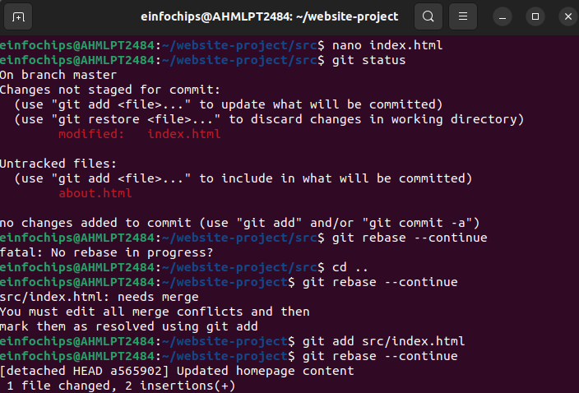

**Push the Rebased Branch**:  
git push -f origin feature/update-homepage

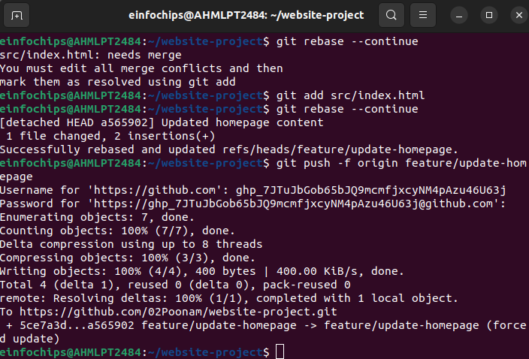

#### **Exercise 4: Pulling and Collaboration (10 minutes)**

1. **Pull Changes from Remote**:

Ensure the main branch is up-to-date:  
  
git checkout main

git pull origin main



1. **Simulate a Collaborator's Change**:
   * Make a change on GitHub directly (e.g., edit index.html).
2. **Pull Collaborator's Changes**:

Pull the changes made by the collaborator:  
git pull origin main

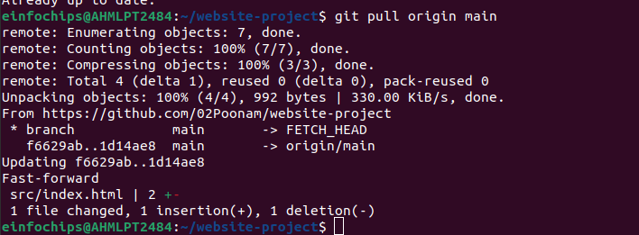

#### **Exercise 5: Versioning and Rollback (15 minutes)**

1. **Tagging a Version**:

Tag the current commit as v1.0:  
git tag -a v1.0 -m "Version 1.0: Initial release"

git push origin v1.0

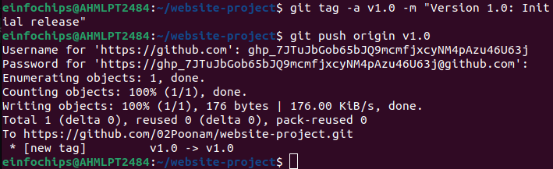

1. **Made a Change that Needs Reversion**:

Modified index.html:  
echo "<p>Incorrect update</p>" >> src/index.html

git add src/index.html

git commit -m "Incorrect update"

git push origin main

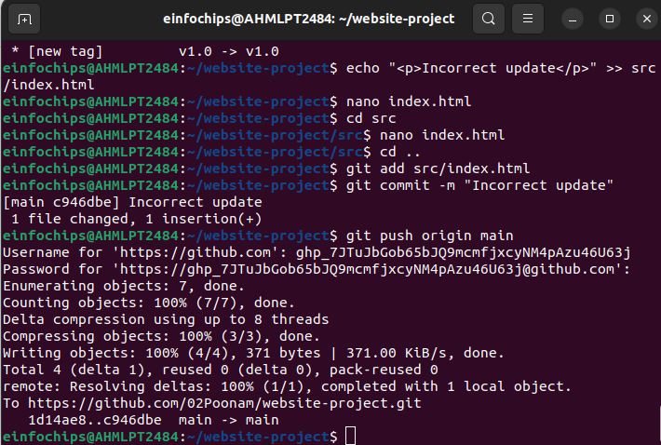

1. **Revert to a Previous Version**:

Use git revert to undo the last commit:  
git revert HEAD

git push origin main

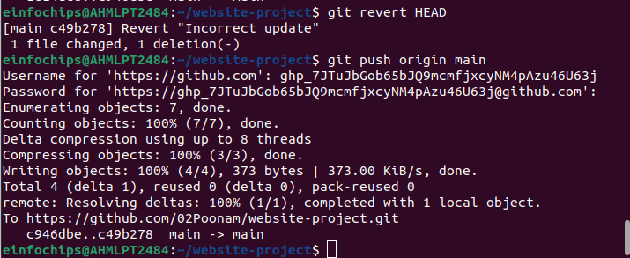

Alternatively, reset to a specific commit (use with caution):  
sh  
Copy code  
git reset --hard v1.0

git push -f origin main

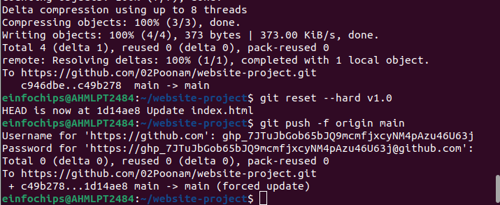

#### **Extra activities (10 minutes)**

1. **Stashing Changes**:

Make some local changes without committing:  
  
echo "<p>Uncommitted changes</p>" >> src/index.html

Stash the changes:  
git stash

Apply the stashed changes:  
git stash apply

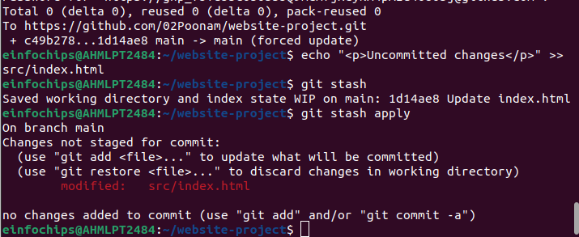

1. **Viewing Commit History**:

Use git log to view commit history:  
git log –oneline

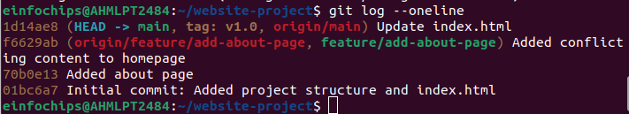

1. **Cherry-Picking Commits**:

Create a new branch and cherry-pick a commit from another branch:  
git checkout -b feature/cherry-pick

git cherry-pick <commit-hash>

git push origin feature/cherry-pick



 

 

 

 

 

 

 

 